A Case Study for a Global City in a High Income Country- London
Why is London a Global City?
- Is an Alpha++ global city along with New York meaning it is extremely well connected to the global economy and dominates the UK economy with 20% of the UK’s income coming from London.
- Has a wide range of MNCs basing their Headquarters there including Google and is the location of UK’s financial sector including the UK stock exchange the FTSE.
- Has a multicultural population with 22% of the population not speaking English as their first language.
- Location of the national government with the houses of parliament.
- Has a number of world class universities (e.g. Imperial) and a high population of graduates of (58% compared to 38% in the UK)

Challenge 1 faced by London- Housing
House prices have grown quicker than the rest of the UK making property too expensive for many low and middle income workers. Many areas of cheaper and social housing have been redeveloped into areas of high cost apartments forcing the local population to move away. In addition, it is estimated that London has nearly 4000 people that are homeless.
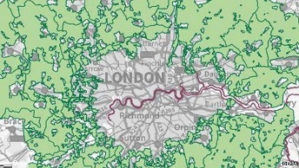
How is the UK government responding to the housing problem?
The government is allowing planning permission for building on greenbelt land across the south east of England. This means more people can live in the south east and commute into London on a daily basis. In addition, housing is being built upon brownfield sites such as the apartments being built in what was once Battersea Powerstation by Malaysian investors.
Challenge 2 faced by London- Transport and Congestion
The population is predicted to grow from 8 million to 10 million over the next few years. This means there will be an increase in air pollution and increased pressure on public transport services such as the tube network which is already heavily congested. In addition, nearly 1 million people commute into London every day putting a huge amount of pressure on London’s public transport networks.
How is the UK government responding to the transport problems?
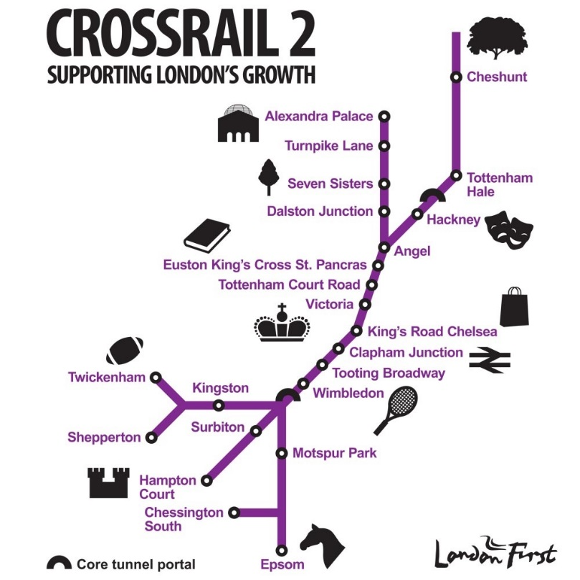
- Congestion charging in central London: the government has introduced congestion zones where people travelling by car have to pay a fee to deter people from travelling by car and therefore reduce congestion and air pollution.
- Crossrail 2 will connect the north east of London with the south west. It is estimated that when complete it will ease congestion on existing underground routes and reduce journey times for commuters. In addition, it is forecast to have the following social and economic benefits:
- Support 200, 000 jobs across the South East of England
- Support the development of 200,000 new homes across the south East
- Increase London’s rail capacity by 10%
- Allow an extra 270, 000 people to travel into London during peak times

Space for a Mind Map

