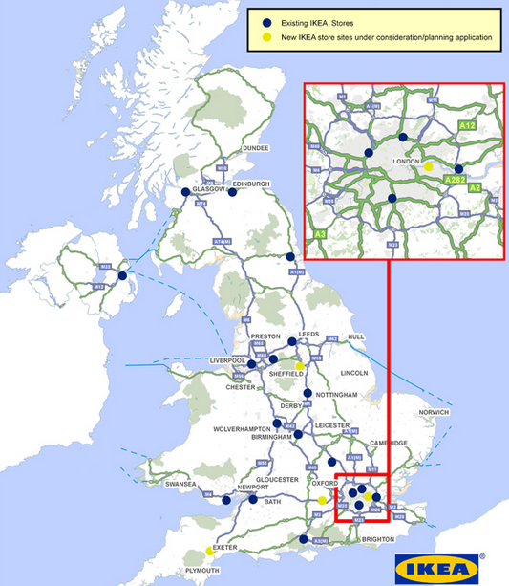
Multinational Companies in the UK-IKEA
IKEA has located its stores in cities around the UK. It is typical of a High Income Country as it has people with high levels of disposable income that can afford consumer products.
In addition, the UK has a well educated labour market with universities and colleges meaning it can recruit the highly skilled labour it needs to manage the stores.
MNCs like IKEA create a Positive Multiplier Effect as they create jobs indirectly as there is an increased demand for manufacturing products that are sold in store.

Advantage | Location factor | Positive effect | Negative effect | Explanation
Next to the M1
More congestion on nearby roads such
Near to Meadowhall a retail park and Centertainment so
Customers choose to shop in IKEA instead of other stores in Sheffield
In the outer suburbs of Sheffield instead of the CBD so…
500 jobs are created
IKEA needs to recruit from a large population nearby so…
Local manufacturing businesses will get orders from IKEA
Next to other transport links such as the tram so…
IKEA stores need a threshold population of 2 million people within 40-60 miles. The Sheffield store has this so…

