Ecosystem Management in the UK: The Upper Derwent Valley
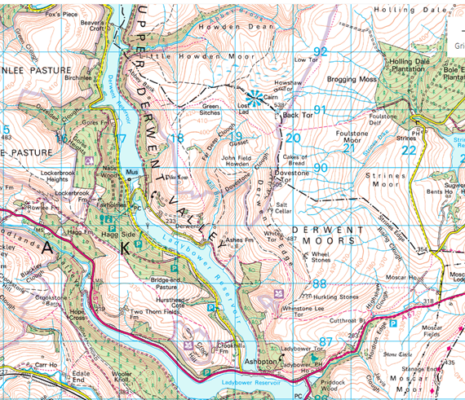
Located in the Dark Peak – the northern half of the Peak District National Park. To the West of Sheffield, and to the East of Manchester. To the north of the busy A57 Snake Pass road.
Description of the Area:
The Dark Peak is known for its exposed moorlands, and the open undulating high gritstone plateau with extensive blanket peat covered by cottongrass, bog and heather moorland. Below the moorland, steep-sided cloughs (valleys) may be lined with ancient areas of oak-birch woodlands. Some of the steep valley slopes have been planted with interlocking blocks of coniferous and mixed plantation woodland while others support acid grassland.
Plateaux’s – flatter tops to the uplands – not angular tops like some mountain areas.
Steeper sides forested with commercial conifer plantations, old oak-birch woodlands, and mixed plantations
Derwent Moors
Ladybower Reservoir
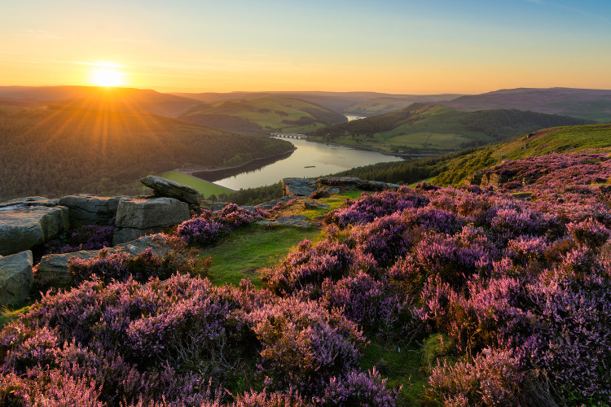
Cotton grass, bracken and bilberry amongst the heather.
Heather moorland on top of peat (a dark brown compost like soil)
Gritstone outcrops

Key Features of the Upper Derwent Ecosystem
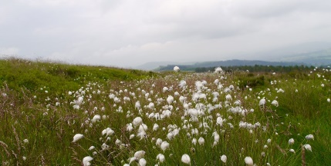 | Cottongrass – deep, wet, blanket bog on the plateau supports the growth of cottongrass. These are internationally very rare, with Britain having approximately 20% of the world’s coverage.
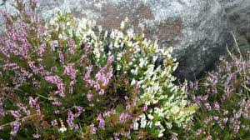 | Heather – small scrub like bushes with purple or white flowers in summer.
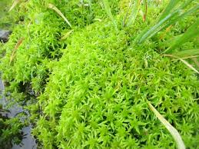 | Sphagnum moss – a damp sponge like moss that contains many invertebrates: a useful food source for many animals.
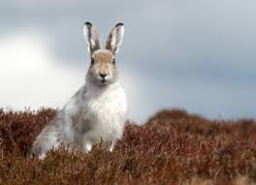 | The Peak District is home to the only population of Mountain Hares in England. Brown in summer, they develop a white coat in winter for camouflage on the snowy hills.
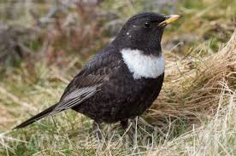 | Ring Ouzel (pictured), Merlin, Curlew, Peregrine are also found in this precious ecosystem.
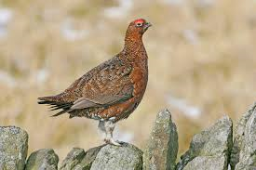 | Red Grouse – along with rough grazing by sheep, and commercial forestry on the valley slopes, this is one of the main economic activities on the moors. Red Grouse are commercially bred on the moors, with people paying to shoot them in late summer and early autumn.

Why does this ecosystem need management?
- The blanket peat bogs are very delicate. The Derwent moors are very popular with walkers (tourists), and they erode the blanket peat bogs very easily.
- In summer, the peat bogs and heather dries out and this makes is at great risk from fires.
- The blanket peat bogs act like a sponge, soaking up rain from storms and slowly releasing it. If the peat is eroded, the risk of flooding downstream from the Derwent moors increases.
- The moors support a rich, but also under threat range of species (named above). Without management these are at increased risk.
- Without management, the heather grows too bushy and is of no use to the Red Grouse as a food source.

Management of the Upper Derwent Moorland Ecosystem
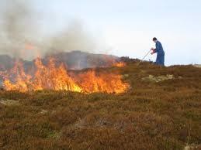  Heather Burning  The heather covering the moorland is an important habitat. Short (young) heather provides food for sheep and red grouse, and shelter and nest sites for some ground-nesting birds. Taller (older) heather provides shelter and nest sites for birds and other wildlife.  However, if left undisturbed, heather plants will live for over 20 years and the stems eventually become very tough and woody, with few leaves or flowers. Consequently, gamekeepers manage the heather by burning it when the stems get to about wellie-top height. They burn different patches each year in rotation, so that there are always areas of short heather and tall heather close together.  Burning takes place over the winter and in early spring when there are no birds nesting on the ground and the soil is generally wet. The fires are small and carefully controlled so they don’t spread or damage the peaty soil. The following year new green shoots grow from underground stems and seeds. | 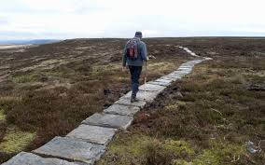  Flagstone Footpaths  The blanket bog peat is very easily eroded by walkers. To protect this very delicate ecosystem, stone flags from old factories are airlifted by helicopter, and teams of rangers use them to create a hard surface across the moors for walkers to use. This stops the walkers trampling on the delicate ecosystem either side. | 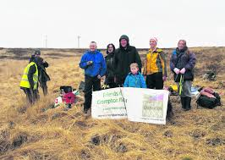  Replanting schemes  Where vegetation has been damaged by walkers, or by fires, teams of volunteers have replanted areas with sphagnum moss, heather, and other moorland plants. This helps to maintain the biodiversity, and also reduces the amount of surface runoff that flows of the land, helping reduce the risk of flooding downstream.
 | 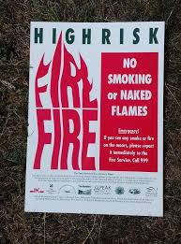  Fire Risk Education  Teams of National Park wardens work to educate and inform visitors about the risk of fires. Notices are displayed, and in high risk areas, the use of disposable BBQ’s are prohibited.  Firefighting equipment is available to put out very small fires, and the fire service has four wheeled drive vehicles that, along with helicopters, can access and help control larger fires. This aims to reduce the damage to the ecostytem caused by fire. | 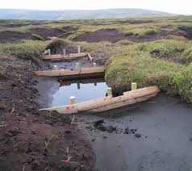  Gully Blocking  Where bare peat has been exposed, small gullies are easily eroded. These stream gullies start to dry the blanket peat bog out, leading to loss of habitats, increased fire risk, and further erosion. Rainwater quickly flows off the land, inceasing flood risk downstream.  To stop this happening, simple wooden barriers are placed across the gullies, blocking the water from running off. This traps water on the moor, and helps maintain the blanket peat bogs and the ecosytems dependent on them.

