Tourism Revision Sheet
National Parks: large areas of countryside protected from being built upon.
Why set up?
To protect the beautiful scenery, rare wildlife habitats and preserve historical sites for people to access and enjoy.
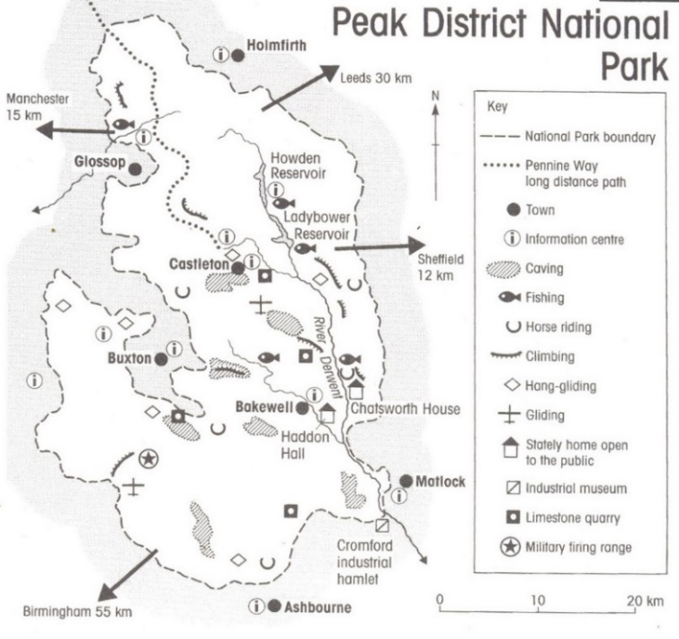
Conflicts: Farmers, tourists and land owners come into conflict over how the land should be used in National Parks.
Honeypot sites: Towns and attractions where large numbers of tourists visit, particularly at weekends and in the summer months (e.g. Castleton and Bakewell in the Peak District)
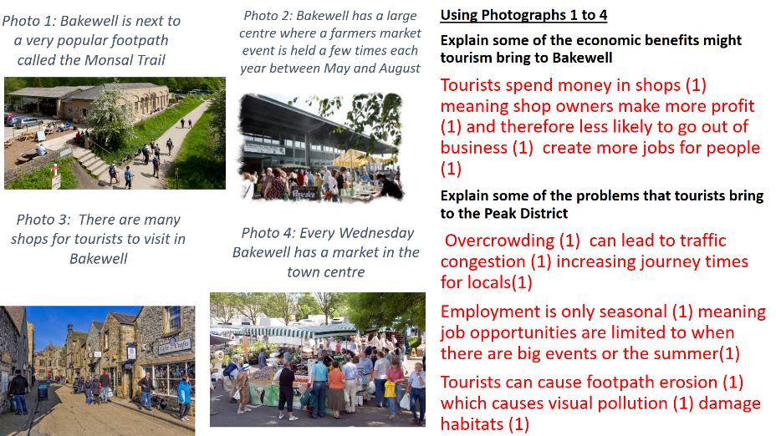
Exam Questions on Honeypot sites like Bakewell in National Parks.
Strategies for Managing Tourism in the Peak District
- Sensitive areas fenced off e.g. Mam Tor
- Badly eroded areas reseeded/ revegetated e.g. Mam Tor
- Signs to inform walkers to stay on the path e.g. Mam Tor.
- Footpaths rerouted around farms e.g. Castleton.
- Signposts, stiles and gates maintained by Park Rangers and Voluntary Park Rangers.
- Visitor centres to educate visitors e.g. Castleton, Bakewell, Edale, Upper Derwent
- Provision of picnic areas with litter bins e.g. Upper Derwent
- Car parks e.g. Castleton, one way systems e.g. Chapel en le Frith and public transport e.g. buses and trains from Manchester and Sheffield
- Development of alternative honeypots to direct visitors to other attractions (For example Fairholmes Visitor Centre alongside the Derwent Reservoir)
- Grants for farmers to replant hedgerows, maintain dry stone walls

Space for Revision Notes

